SIMATS ENGINEERING

ASSESSMENT TOOL 1

COURSE CODE: CSA14 COURSE NAME: COMPILER DESIGN

COURSE OUTCOME COVERED
CO3: Analyze syntax-directed translation method using synthesized and inherited attributes to generate a Parser Tree. (BL4)

Assessment Tool Weightage: 40%

QUESTIONS:5 Total Marks:100
Annexure A

EXPERIMENTS

Code of Conduct:
I _Sruthi Rithika P(192521407) (Name / Reg No) certify that this submission is my original work and that I have adhered to the guidelines specified for this assessment.
I understand that any violation of academic integrity rules will result in disciplinary action.
Signature of the student: Sruthi Rithika P

Annexure A

EXPERIMENTS
Compiler Design Laboratory – C Programming Questions Experiment 1: Three-Address Code Generation Objective:
To implement an Intermediate Code Generator that produces Three-Address Code (TAC) for a given arithmetic expression.
Problem Statement:
The intermediate code generation phase of a compiler translates source-level expressions into a machine-independent representation. One of the most commonly used intermediate representations is Three-Address Code (TAC), where each instruction contains at most three addresses and uses temporary variables to represent intermediate results. TAC simplifies expression evaluation and facilitates optimization and code generation.
Task:
Write a C program that accepts an arithmetic expression containing operands, operators (+, -, *,
/), and parentheses, and generates the corresponding Three-Address Code representation using temporary variables (t1, t2, …).
Sample Input:
a + b * c - d
Sample Output:
t1 = b * c t2 = a + t1
t3 = t2 - d
Requirement:
Implement the program in C and generate TAC in the correct order of operator precedence.

Experiment 2: FIRST Set Computation Objective:
To compute the FIRST set of all non-terminals in a context-free grammar used for predictive parsing.
ProblemStatement:
The FIRST set of a grammar symbol is the set of terminals that can appear at the beginning of strings derived from that symbol. FIRST sets are essential for constructing predictive parsers and LL(1) parsing tables.
Grammar:
S → AaAb | BbBa

A → ε
B → ε
Task:
Write a C program to compute and display the FIRST() set for each non-terminal (S, A, and B) in the given grammar.
Expected Output:
FIRST(S) = { a, b }
FIRST(A) = { ε }
FIRST(B) = { ε }
Requirement:
Implement the algorithm for FIRST set computation in C, considering epsilon productions and recursive derivations.

Experiment 3: FOLLOW Set Computation Objective:
To compute the FOLLOW set of all non-terminals in a context-free grammar.
ProblemStatement:
The FOLLOW set of a non-terminal is the set of terminals that can appear immediately to its right in some sentential form. FOLLOW sets are required for constructing LL(1) predictive parsing tables.
Grammar:
S → AaAb | BbBa
A → ε
B → ε
Task:
Write a C program to compute and display the FOLLOW() set for each non-terminal (S, A, and B) in the given grammar.
Expected Output:
FOLLOW(S) = { $ }

FOLLOW(A) = { a, b }

FOLLOW(B) = { a, b }
Requirement:
Implement the FOLLOW set computation algorithm in C, including handling of epsilon productions and the end-of-input marker ($).

Experiment 4: Implementation of the Back End of a Compiler Objective:
To simulate the back end phase of a compiler by generating target-like instructions from intermediate code.

Problem Statement:
The back end of a compiler translates intermediate code into target machine instructions. This phase includes instruction generation and simple register allocation. A basic implementation may convert assignment and arithmetic operations into assembly-like instructions using registers.
Task:
Write a C program that accepts simple Three-Address Code statements and generates corresponding target machine instructions.
Sample Input:
t1 = b * c t2 = a + t1
Sample Output:
MOV R0, b MUL R0, c MOV t1, R0 MOV R1, a ADD R1, t1
MOV t2, R1
Requirement:
Implement a simplified code generation module in C that converts arithmetic TAC statements into assembly-style instructions using registers.

Experiment 5: Lexical Analyzer in C Objective:
To develop a Lexical Analyzer that identifies identifiers, constants, and operators while ignoring whitespace and comments.
Problem Statement:
A lexical analyzer is the first phase of a compiler. It scans the source program and groups characters into meaningful tokens. The analyzer must ignore redundant spaces, tabs, new lines, single-line comments (//), and multi-line comments (/* ... */), while recognizing identifiers, numeric constants, keywords, and operators.
Task:
Write a C program that reads a source program from a file or standard input and performs lexical analysis to identify and display the following tokens:
- Identifiers
- Numeric Constants

- Keywords
- Arithmetic Operators
- Relational Operators
- Assignment Operators
- Special Symbols / Delimiters
The program should ignore:
- Spaces
- Tabs
- New lines
- Single-line comments
- Multi-line comments
Sample Input: int a = 10; float b = 20.5;
// This is a comment a = a + b;
Sample Output:
Keyword : int Identifier : a Operator : = Constant : 10 Keyword : float Identifier : b Operator : = Constant : 20.5 Identifier : a Operator : = Identifier : a Operator : +

Identifier : b
Requirement:
Implement the lexical analyzer in C using character-by-character scanning and token recognition techniques.

ANSWER:
Experiment 1: Three-Address Code Generation

AIM:
To generate Three-Address Code (TAC) for an arithmetic expression using temporary variables and operator precedence.

PSEUDO CODE:
START
Read an arithmetic expression. Remove unnecessary spaces.
Convert the expression from infix to postfix: If operand → add to postfix.
If '(' → push into stack. If ')' → pop until '('.
If operator → pop operators with higher/equal precedence, then push current operator.
Scan postfix expression:
If operand → push into operand stack. If operator:
Pop right operand.
Pop left operand.
Create a temporary variable. Generate TAC.
Push temporary variable.
Display the generated TAC. STOP

CODE:
#include <stdio.h> #include <string.h> #include <ctype.h> #define SIZE 100 char opStack[SIZE]; char postfix[SIZE]; int opTop = -1;
int postTop = 0; int temp = 1;
int precedence(char op){ if (op == '+' || op == '-')
return 1;
if (op == '*' || op == '/') return 2;
return 0;
}
void pushOperator(char ch){ opStack[++opTop] = ch;
}
char popOperator(){
return opStack[opTop--];
}
int main(){
char expression[SIZE]; char operands[SIZE][20]; int operandTop = -1;

int i; char ch;
printf("Enter expression: "); fgets(expression, SIZE, stdin);
/* Convert infix to postfix */
for (i = 0; expression[i] != '\0'; i++){ ch = expression[i];
if (isspace(ch)) continue;
if (isalnum(ch)){ postfix[postTop++] = ch;
}
else if (ch == '('){ pushOperator(ch);
}
else if (ch == ')'){
while (opTop >= 0 && opStack[opTop] != '(') postfix[postTop++] = popOperator();
if (opTop >= 0) popOperator();
}
else if (ch == '+' || ch == '-' || ch == '*' || ch == '/'){ while (opTop >= 0 && opStack[opTop] != '(' &&
precedence(opStack[opTop]) >= precedence(ch))
{
postfix[postTop++] = popOperator();
}

pushOperator(ch);
}
}
while (opTop >= 0)
postfix[postTop++] = popOperator(); postfix[postTop] = '\0';
/* Generate TAC */ printf("\nThree Address Code:\n"); for (i = 0; postfix[i] != '\0'; i++){
ch = postfix[i]; if (isalnum(ch)){
operands[++operandTop][0] = ch; operands[operandTop][1] = '\0';
}else{
char left[20], right[20], result[20]; strcpy(right, operands[operandTop--]); strcpy(left, operands[operandTop--]); sprintf(result, "t%d", temp++);
printf("%s = %s %c %s\n", result, left, ch, right); strcpy(operands[++operandTop], result);
}
}
return 0;
}

OUTPUT:

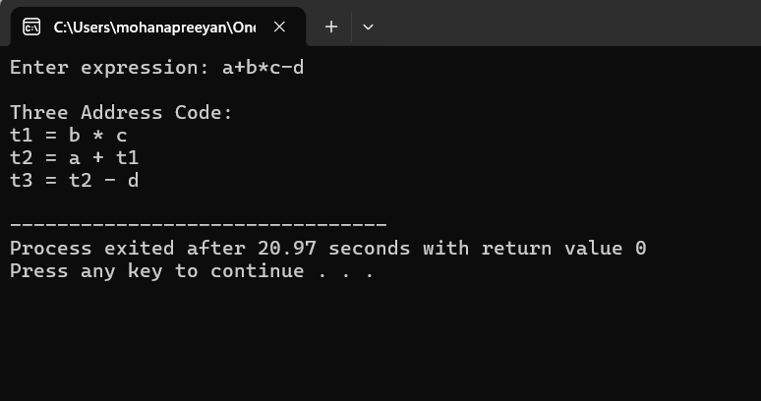

Experiment 2 — First Set Computation

AIM:
To compute the FIRST set of the non-terminals of a given grammar.

PSEUDO CODE:

START

Read number of non-terminals. Read all non-terminals.
Read number of productions. For every production:
Store left-hand side and right-hand side.

Initialize FIRST sets as empty. Repeat until no FIRST set changes:

For every production A → X1 X2 ... Xn: Examine symbols from left to right.
If Xi is a terminal:

Add Xi to FIRST(A).

Stop.

If Xi is epsilon:

Add epsilon to FIRST(A). Stop.
If Xi is a non-terminal:

Add FIRST(Xi), except epsilon, to FIRST(A). If FIRST(Xi) does not contain epsilon:
Stop.

If every symbol can produce epsilon: Add epsilon to FIRST(A).
Display FIRST set of every non-terminal. STOP

CODE:
#include <stdio.h> #include <string.h> #include <ctype.h> #define MAX_NT 20
#define MAX_PROD 50

#define MAX_LEN 50

#define EPS '#' typedef struct
{

char left;

char right[MAX_LEN];

} Production;

char nonTerminal[MAX_NT]; int ntCount;
Production grammar[MAX_PROD]; int prodCount;
char first[MAX_NT][MAX_LEN]; int firstCount[MAX_NT];
int findNT(char symbol)

{

int i;

for (i = 0; i < ntCount; i++)

{

if (nonTerminal[i] == symbol) return i;
}

return -1;

}

int addToSet(char set[], int *count, char symbol)

{

int i;

for (i = 0; i < *count; i++)

{

if (set[i] == symbol) return 0;
}

set[*count] = symbol; (*count)++;
return 1;

}

int hasEpsilon(int index)

{

return addToSet(first[index], &firstCount[index], EPS);

}

int main()

{

int i, j, k;

int changed;

printf("Enter number of non-terminals: "); scanf("%d", &ntCount);
printf("Enter non-terminals: "); for (i = 0; i < ntCount; i++)
scanf(" %c", &nonTerminal[i]); printf("Enter number of productions: ");

scanf("%d", &prodCount);

printf("\nEnter productions without spaces.\n"); printf("Use # for epsilon.\n\n");
for (i = 0; i < prodCount; i++)

{

for (i = 0; i < prodCount; i++){ printf("Production %d: ", i + 1);
scanf("%c=%s", &grammar[i].left, grammar[i].right);

}

do{

changed = 0;

for (i = 0; i < prodCount; i++){ for (i = 0; i < prodCount; i++){
int leftIndex = findNT(grammar[i].left); int allNullable = 1;
for (j = 0; grammar[i].right[j] != '\0'; j++){

for (j = 0; grammar[i].right[j] != '\0'; j++){ char symbol = grammar[i].right[j];
/* Epsilon */

if (symbol == EPS)

if (addToSet(first[leftIndex], &firstCount[leftIndex], EPS)) { if (addToSet(first[leftIndex],&firstCount[leftIndex], EPS)){
changed = 1;

}

break;

}

/* Terminal */

if (!isupper(symbol))

{

if (addToSet(first[leftIndex],

&firstCount[leftIndex], symbol))
{

if (addToSet(first[leftIndex],&firstCount[leftIndex],symbol)) changed = 1;
}

allNullable = 0; break;
}

/* Non-terminal */

int symbolIndex = findNT(symbol); if (symbolIndex == -1)
{

allNullable = 0; break;
}

/* Copy FIRST(symbol), except epsilon */ for (k = 0; k < firstCount[symbolIndex]; k++)

{

if (first[symbolIndex][k] != EPS)

{

if (addToSet(first[leftIndex],

&firstCount[leftIndex], first[symbolIndex][k]))
{

changed = 1;

}

}

}

/* If symbol cannot derive epsilon, stop */ int nullable = 0;
for (k = 0; k < firstCount[symbolIndex]; k++)

{

if (first[symbolIndex][k] == EPS)

{

nullable = 1; break;
}

}

if (!nullable)

{

allNullable = 0;

break;

}

}

if (allNullable)

{

if (addToSet(first[leftIndex],

&firstCount[leftIndex], EPS))
{

changed = 1;

}

}

}

} while (changed); printf("\nFIRST SETS\n\n"); for (i = 0; i < ntCount; i++)
{

printf("FIRST(%c) = { ", nonTerminal[i]); for (j = 0; j < firstCount[i]; j++)
{

if (first[i][j] == EPS) printf("epsilon ");
else

printf("%c ", first[i][j]);

}

printf("}\n");

}

return 0;

}

OUTPUT:

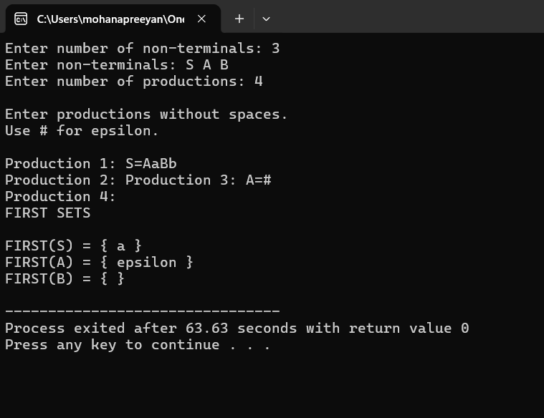

Experiment 3 — Follow Set Computation

AIM:
To compute the FOLLOW set of all non-terminals in a given grammar.

PSEUDO CODE:
START

Read non-terminals.

Read productions.

First calculate FIRST sets.

Put '$' into FOLLOW(start symbol). Repeat until no change:
For every production A → X1 X2 ... Xn: Scan every symbol Xi.
If Xi is a non-terminal:

Consider the symbols after Xi. If the next symbol is a terminal:
Add it to FOLLOW(Xi).

If the next symbol is a non-terminal:

Add FIRST(next symbol), except epsilon. If all symbols after Xi can produce epsilon:
Add FOLLOW(A) to FOLLOW(Xi).

Display FOLLOW sets. STOP

CODE:

#include <stdio.h> #include <string.h> #include <ctype.h> #define MAX_NT 20
#define MAX_PROD 50
#define MAX_LEN 50 #define EPS '#' #define END '$' typedef struct
{
char left;
char right[MAX_LEN];
} Production;
char nonTerminal[MAX_NT]; int ntCount;
Production grammar[MAX_PROD]; int prodCount;
char first[MAX_NT][MAX_LEN]; int firstCount[MAX_NT];
char follow[MAX_NT][MAX_LEN]; int followCount[MAX_NT];
int findNT(char symbol)
{
int i;
for (i = 0; i < ntCount; i++)
{
if (nonTerminal[i] == symbol) return i;
}

return -1;
}
int addSymbol(char set[], int *count, char symbol)
{
int i;
for (i = 0; i < *count; i++)
{
if (set[i] == symbol) return 0;
}
set[*count] = symbol; (*count)++;
return 1;
}
int contains(char set[], int count, char symbol)
{
int i;
for (i = 0; i < count; i++)
{
if (set[i] == symbol) return 1;
}
return 0;
}
/* FIRST calculation */ void calculateFirst()
{
int changed; do

{
changed = 0;
for (int p = 0; p < prodCount; p++)
{
int A = findNT(grammar[p].left); int nullable = 1;
for (int i = 0; grammar[p].right[i] !='\0'; i++)
{
char symbol = grammar[p].right[i]; if (symbol == EPS)
{
if (addSymbol(first[A],
&firstCount[A], EPS))
changed = 1;
nullable = 1; break;
}
if (!isupper(symbol))
{
if (addSymbol(first[A],
&firstCount[A], symbol))
changed = 1;
nullable = 0; break;
}
int B = findNT(symbol);
for (int j = 0; j < firstCount[B]; j++)

{
if (first[B][j] != EPS)
{
if (addSymbol(first[A],
&firstCount[A], first[B][j]))
changed = 1;
}
}
if (!contains(first[B],
firstCount[B], EPS))
{
nullable = 0; break;
}
}
if (nullable)
{
if (addSymbol(first[A],
&firstCount[A], EPS))
changed = 1;
}
}
} while (changed);
}
/* FOLLOW calculation */ void calculateFollow()

{
int changed;
/* Start symbol */
addSymbol(follow[0], &followCount[0], END); do
{
changed = 0;
for (int p = 0; p < prodCount; p++)
{
int A = findNT(grammar[p].left);
int length = strlen(grammar[p].right); for (int i = 0; i < length; i++)
{
char current = grammar[p].right[i]; if (!isupper(current))
continue;
int B = findNT(current); int canBeEmpty = 1;
/* Examine symbols to the right */ for (int j = i + 1; j < length; j++)
{
char next = grammar[p].right[j]; if (next == EPS)
{
canBeEmpty = 1; break;
}
/* Terminal */
if (!isupper(next))

{
if (addSymbol(follow[B],
&followCount[B], next))
changed = 1;
canBeEmpty = 0; break;
}
/* Non-terminal */ int C = findNT(next);
for (int k = 0; k < firstCount[C]; k++)
{
if (first[C][k] != EPS)
{
if (addSymbol(follow[B], &followCount[B],
first[C][k])) changed = 1;
}
}
if (!contains(first[C],
firstCount[C], EPS))
{
canBeEmpty = 0; break;
}
}
if (i == length - 1)

canBeEmpty = 1; if (canBeEmpty)
{
for (int k = 0; k < followCount[A]; k++)
{
if (addSymbol(follow[B],
&followCount[B], follow[A][k]))
changed = 1;
}
}
}
}
} while (changed);
}
int main()
{
int i, j;
printf("Enter number of non-terminals: "); scanf("%d", &ntCount);
printf("Enter non-terminals: "); for (i = 0; i < ntCount; i++)
scanf(" %c", &nonTerminal[i]); printf("Enter number of productions: "); scanf("%d", &prodCount); printf("\nUse # for epsilon.\n\n");
for (i = 0; i < prodCount; i++)
{
printf("Production %d: ", i + 1);

scanf(" %c=%s", &grammar[i].left, grammar[i].right);
}
calculateFirst(); calculateFollow(); printf("\nFOLLOW SETS\n\n"); for (i = 0; i < ntCount; i++)
{
printf("FOLLOW(%c) = { ", nonTerminal[i]); for (j = 0; j < followCount[i]; j++)
{
printf("%c ", follow[i][j]);
}
printf("}\n");
}
return 0;
}

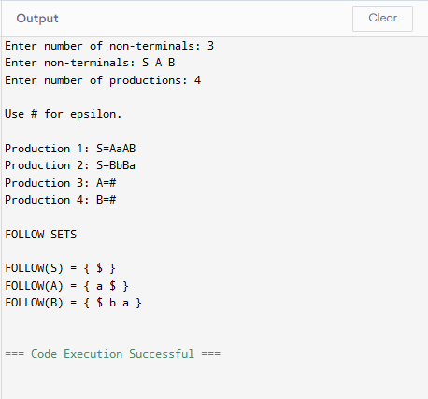
OUTPUT:

Experiment 4: Implementation of the Back End of a Compiler

AIM:
To convert Three-Address Code into simple target machine instructions using registers

PSEUDO CODE:
START
Read number of TAC statements. For each TAC statement:
Read result, operand1, operator and operand2. Select a register.
Generate MOV instruction for operand1. Generate instruction according to operator:
+ → ADD
- → SUB
* → MUL
/ → DIV
Move register contents to result.
Display target code.
STOP

CODE:
#include <stdio.h> int main()
{
int n; int i;
char result[20]; char operand1[20]; char operand2[20]; char operation;
printf("Enter number of TAC statements: "); scanf("%d", &n);
printf("Enter TAC statements:\n"); for (i = 0; i < n; i++) {

scanf("%s = %s %c %s", result,
operand1, &operation, operand2);
printf("\nMOV R%d, %s\n", i, operand1); if (operation == '+')
printf("ADD R%d, %s\n", i, operand2); else if (operation == '-')
printf("SUB R%d, %s\n", i, operand2); else if (operation == '*')
printf("MUL R%d, %s\n", i, operand2); else if (operation == '/')
printf("DIV R%d, %s\n", i, operand2); printf("MOV %s, R%d\n", result, i);
}
return 0;
}

OUTPUT:
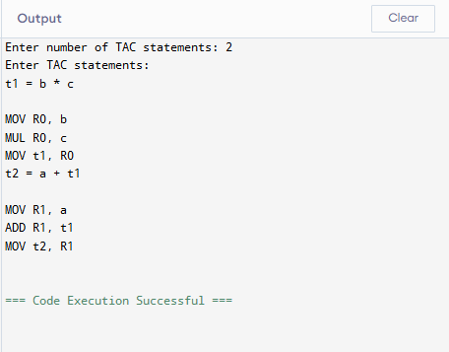

Experiment 5: Lexical Analyzer in C

AIM:
To implement a lexical analyzer that identifies keywords, identifiers, constants, operators and special symbols while ignoring spaces and comments.

PSEUDO CODE:
START
Open the source file.
Read characters one by one. If whitespace:
Ignore it.
If letter or underscore:
Continue reading the complete word. Check whether it is a keyword.
Otherwise identify it as an identifier.
If digit:
Continue reading digits and decimal point. Identify it as a constant.
If '/':
Check next character. If '//':
Ignore until newline.
If '/*':
Ignore until '*/'.
Otherwise:
Identify '/' as arithmetic operator.
If +, -, *, %:
Identify arithmetic operator.
If =, <, >:
Check next character.
Identify assignment or relational operator.
If ; , ( ) { } [ ]:
Identify special symbol.

Continue until EOF. Close file.
STOP

CODE:
#include <stdio.h> #include <string.h> #include <ctype.h> #define MAX 100
const char *keywords[] =
{
"auto", "break", "case", "char",
"const", "continue", "default", "do",
"double", "else", "enum", "extern",
"float", "for", "goto", "if",
"int", "long", "register", "return",
"short", "signed", "sizeof", "static",
"struct", "switch", "typedef", "union",
"unsigned", "void", "volatile", "while"
};
int keywordCount =
sizeof(keywords) / sizeof(keywords[0]);
/* Check whether a word is a keyword */ int checkKeyword(char word[])
{
int i;
for (i = 0; i < keywordCount; i++)
{
if (strcmp(word, keywords[i]) == 0) return 1;
}
return 0;
}

/* Read and display an identifier or keyword */ int scanWord(char str[], int pos)
{
char word[MAX]; int j = 0;
while (isalnum((unsigned char)str[pos]) || str[pos] == '_')
{
word[j++] = str[pos++];
}
word[j] = '\0';
if (checkKeyword(word)) printf("KEYWORD -> %s\n", word);
else
printf("IDENTIFIER -> %s\n", word); return pos;
}
/* Read and display a number */ int scanNumber(char str[], int pos)
{
char number[MAX]; int j = 0;
int decimal = 0;
while (isdigit((unsigned char)str[pos]) || (str[pos] == '.' && decimal == 0))
{
if (str[pos] == '.') decimal = 1;
number[j++] = str[pos++];
}
number[j] = '\0';
printf("CONSTANT -> %s\n", number); return pos;
}

/* Display operators */
int scanOperator(char str[], int pos)
{
char current = str[pos]; char next = str[pos + 1];
/* Relational operators */ if (current == '=' ||
current == '<' || current == '>' || current == '!')
{
if (next == '=')
{
printf("RELATIONAL -> %c%c\n", current, next);
return pos + 2;
}
if (current == '=')
{
printf("ASSIGNMENT -> =\n");
}
else
{
printf("RELATIONAL -> %c\n", current);
}
return pos + 1;
}
/* Arithmetic operators */ if (current == '+' ||
current == '-' || current == '*' || current == '/' || current == '%')

{
printf("ARITHMETIC -> %c\n", current); return pos + 1;
}
return pos;
}
/ Main lexical analyzer */ int main()
{
char line[MAX]; int i;
int length; printf("=====================================\n"); printf(" SIMPLE LEXICAL ANALYZER\n"); printf("=====================================\n");
printf("\nEnter source code.\n"); printf("Enter # alone to finish.\n\n"); while (1)
{
fgets(line, MAX, stdin);
if (strcmp(line, "#\n") == 0 || strcmp(line, "#") == 0) break;
length = strlen(line); i = 0;
while (i < length)
{
/* Ignore whitespace */
if (isspace((unsigned char)line[i]))
{
i++;
continue;
}
/* Handle comments */

if (line[i] == '/' && line[i + 1] == '/')
{
break;
}
if (line[i] == '/' && line[i + 1] == '*')
{
i += 2;
while (i < length)
{
if (line[i] == '*' && line[i + 1] == '/')
{
i += 2;
break;
}
i++;
}
continue;
}
/* Identifier or keyword */
if (isalpha((unsigned char)line[i]) || line[i] == '_')
{
i = scanWord(line, i); continue;
}
/* Numeric constant */
if (isdigit((unsigned char)line[i]))
{
i = scanNumber(line, i); continue;
}

/* Operators */ if (line[i] == '+' ||
line[i] == '-' || line[i] == '*' || line[i] == '/' || line[i] == '%' || line[i] == '=' || line[i] == '<' || line[i] == '>' || line[i] == '!')
{
i = scanOperator(line, i); continue;
}
/* Special symbols */ if (line[i] == ';' ||
line[i] == ',' ||
line[i] == '(' ||
line[i] == ')' ||
line[i] == '{' ||
line[i] == '}' ||
line[i] == '[' ||
line[i] == ']')
{
printf("SPECIAL -> %c\n", line[i]);
i++;
continue;
}
/* Unknown symbol */ printf("UNKNOWN -> %c\n",
line[i]);
i++;
}

}
printf("\nLexical analysis completed.\n"); return 0;
}

OUTPUT:

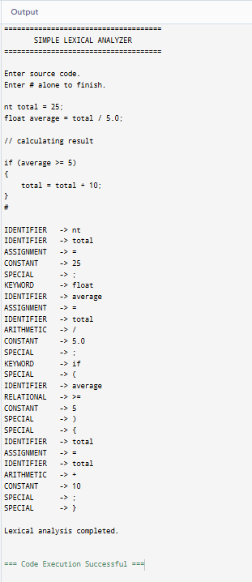

RUBRICS FOR CALCULATION

Criteria | Weightage | Level 4 – Exemplary | Level 3 – Proficient | Level 2 – Developing | Level 1 – Beginning
Understanding of Concepts | 25 | Demonstrates thorough understanding and effectively integrates multiple concepts/technologie  s | Good understanding with proper integration of most concepts | Basic understanding; limited or partial integration | Poor understanding; unable to integrate concepts
Experimental Design | 30 | Well-planned, systematic implementation with optimal solution | Correct implementation with minor issues | Basic implementation with errors or inefficiencies | Incorrect or incomplete implementation
Use of Tools | 20 | Effective and advanced use of tools/technologies with proper configuration | Appropriate use of tools with correct execution | Limited or inconsistent use of tools | Incorrect or minimal use of tools
Analysis of Results | 15 | Insightful analysis with accurate interpretation and validation of results | Good analysis with reasonable interpretation | Basic analysis with limited insights | Poor or incorrect analysis of results
Documentatio n | 10 | Clear, well-structured documentation with diagrams, code, and results | Organized documentation with necessary details | Basic documentation with missing details | Poor or incomplete documentation

